Classification and Clustering in High Dimensions

David Banks, CBER, U.S. Food and Drug Administration
1401 Rockville, MD 20852 banksd@cber.fda.gov

1. CURSE OF DIMENSIONALITY

Classification and cluster analysis are hard in high dimensions because of the Curse of Dimensionality. In high dimensions, the COD implies:
- For large p, nearly all datasets are too small.
- For large p, nearly all datasets are multicollinear (or concurve, the nonparametric generalization of multicollinearity).
- The number of structural functions to consider grows quickly (faster than exponentially) with p.

- CLASSIFICATION

In mass spectrometry, the observation is a curve, not a vector. The curve shows the “number” of proteins in the sample having a given mass (or more precisely, a given mass/charge ratio). Figure 1 gives a hypothetical example of the mass-spec curve.

Figure 1: A Mass-Spectrometry Curve
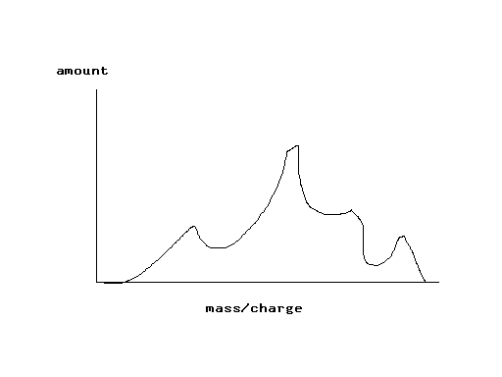

Proteins that have the same mass/charge ratio are not distinguishable.

  - BINNING

One way to use curve data as input to a classification algorithm is to create bins. This discretizes the curve, creating data that are vectors.

The width of the bin should reflect the point-spread function of the mass-spectrometry instrument.

But this does not address the Curse of Dimensionality.

To handle COD issues, one can use:
- Stepwise discriminant analysis
- Classification trees
- Flexible nonparametric discriminant analysis (Hastie and Tibshirani, 1995).
The last may be best; it fits separating surfaces of the form:

_{r}
f(x) =  h_{i}( _{i}  x).
^{i=1}

  - CURVE DATA

Land and Friedman (1994) give a method for classification using curve data. For a training sample such that

Type 1: u1(x), …, un(x)
Type 2: v1(x), …, vm(x)

One seeks a function f(x) such that

 f(x) u_{i}(x) dx > 0 for all i

 f(x) v_{j}(x) dx < 0 for all j.

To account for COD issues, one requires f(x) to be very smooth and often zero. The typical result is a step function that is non-zero only at the intervals on which Type 1 and Type 2 curves are crucially different.

The figure below shows examples of Type 1 and Type 2 curves, with the function f denoted by a bold line.

Figure 2: Land and Friedman Method for Curve Data.
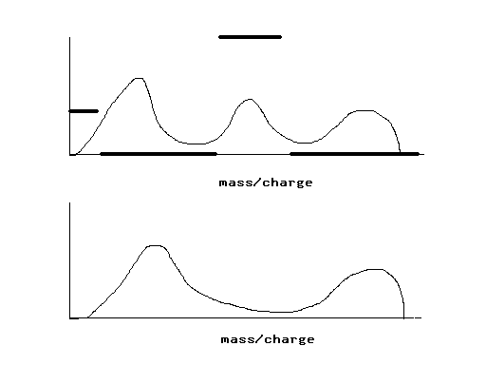

- CLUSTERING

When clustering large datasets in high dimensions one finds:
- The process is sequential and hence unstable
- Cluster structure can occur at all scales.
- Noise variables are ruinous; remove them first if possible
- Cases may cluster one way with respect to some variables and differently with respect to others.

Figure 3 shows a parallel coordinate plot of eight cases, with seven variables for each case. For each case, a line links the seven observations on that case.

Note that in terms of variables X₁, X₂, and X₃, the graph shows strong cluster structure, with cases corresponding to circles and squares separating very cleanly on each axis. Similarly, for variables X₄, X₅, and X₆, the cases no longer cluster in terms of squares and circles, but they do cluster strongly in terms of color, black or white, for each axis. Finally, for variable X₇, there does not seem to be any cluster structure at all.

Instead of having the graphical image show axes meeting at right angles (which obviously breaks down when p > 3), parallel coordinate plots align each axis in parallel. The point that represents an observation in Cartesian systems becomes a line, linking the values of the observation on each axis. and the black and white as denoting parents and non-parents.

Figure 3: Parallel Coordinate Plot with Two Cluster Structures.
X₁

X₂

X₃

X₄

X₅

X₆

X₇

One would like to find the ordering of the axes that best displays the separate cluster-and-variable structures. This requires a search of the p! possible orderings.

It also reduces the search problem to a batch of univariate cluster analyses, aligned by some measure of cross-analysis agreement.

3.1 Kohonen’s Self-Organizing Maps

In proteomics, people do something different from standard hierarchical agglomerative cluster analysis. They want to
- Put similar cases near each other
- Create a 2-D or 3-D view of high-dimensional data.
They often use Kohonen’s Self-Organizing Maps (SOMs) or Multidimensional scaling to achieve these ends.

Kohonen’s SOM is a bit ad hoc, and derives from an analogy with neural nets. One starts with a 2-D or 3-D array of points, where each point is tagged by a vector.

To generate a SOM, one takes the sample values in random order and assigns each to the point in the array whose tag is closest to the sample vector.

When a sample vector is assigned to a point, the array tag (and the adjacent tags) are shrunk towards the sample vector value.

The result from the use of a SOM is not unique. The implicit distance metric is not explicit. There is no available theory of significance testing. The only formal SOM property is a recent result that under i.i.d. sampling, the SOM converges to a single image.

3.2 MULTIDIMENSIONAL SCALING

Multidimensional scaling is a procedure that takes a proximity matrix between cases, and then finds locations for the cases in a low-dimensional space that conform, as closely as possible, to the given inter-case proximities. In practice, the proximity matrix is usually measured with error, and one represents the cases by estimating locations in a two-dimensional plot that respect, as closely as possible, the orderings implied by the elements of the proximity matrix.
To make the multidimensional scaling problem concrete, suppose one has a list of United States cities and knows the time required for driving between each pair of cities. The inter-city proximity matrix contains the drive time, and the multidimensional scaling solution looks very much like the map of the United States (in some random orientation, since compass points are irrelevant to the algorithm). Minor distortions in the map distances are caused when mountain ranges force the roadways to take less direct paths, or when different routes have roads with substantially different speed limits.
Now suppose that instead of driving time one has a matrix of flight time on commercial aviation. For this proximity matrix, the multidimensional scaling solution is highly distorted because United States carriers use the hub-and-spoke system. Passengers traveling from a small city to a distant small city must generally change airplanes at an intermediate large city. As a consequence, the two-dimensional map built from such data tends to place the large cities (i.e., the hub airports) in a central circle, and then the small cities are splayed around on the outer half of a circle centered on their nearest hub airport. The air travel solution tends to have more “stress” than road travel solution, since there is more intrinsic incompatibility within the proximity matrix used for flying.
Stress is an important concept in multidimensional scaling, and it will drive much of the subsequent discussion. Suppose the proximity matrix contains values r_{ij}, those being interpretable as the approximate distance between case i and case j, and let d_{ij} represent the fitted distances between case i and case j in a Euclidean space of fixed dimension. (the r_{ij} will not, in general, satisfy the properties of a true metric, but the d_{ij} must). Let f (·) be the monotone deformation function used by the multidimensional scaling algorithm to bring the proximities as near to the fitted distances as possible. Then the raw stress value of the configuration is given by:
Φ =  [ d_{ij} – f(r_{ij}) ]²
where Φ can be viewed as a measure of the lack of fit. There are several other measures that may be used instead of stress, but most of these are quite similar in spirit and typically are based on sums of squares, perhaps weighted or penalized in some way.
In practice, multidimensional scaling is highly sensitive to outliers. For example, suppose one is building a proximity matrix from driving times, but that along one leg of the trip, the driver has a breakdown and must wait a day while the automobile is fixed. This aberration in the data introduces enormous stress in the multidimensional scaling problem and frequently distorts the answer; it may happen that the resulting low-dimensional map no longer resembles the United States at all, and that crucial interpretability is lost. More commonly, a few large, aberrant values lead researchers to falsely conclude that the appropriate dimension for the multidimensional scaling solution is larger than it should be; the outlier causes the corresponding case to sit on top of a “mountain” in ³ rather than lie in a planar map in ².

- CONCLUSIONS

- Proteomic analysis poses new challenges: curve data, complex error structure, calibration, and tests of significance are key problems.
- We must hope for simple signals in the data.
- Consider using multidimensional scaling instead of self-organizing maps.



